Timeseries database using influxDB on AWS EC2

Step1: Install influxDB on AWS EC2

* Connect to the EC2 and type the below commands -

sudo curl -sL https://repos.influxdata.com/influxdb.key | sudo apt-key add -

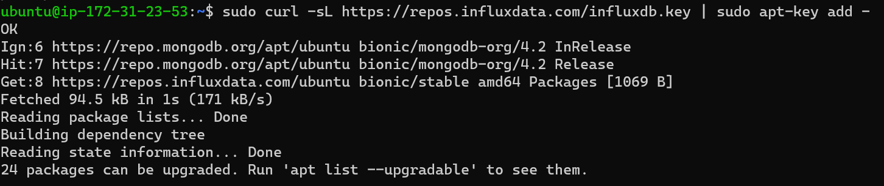

* Create a repository file

sudo echo "deb https://repos.influxdata.com/ubuntu bionic stable" | sudo tee /etc/apt/sources.list.d/influxdb.list

* Update the system

sudo apt update

* Install influxDB

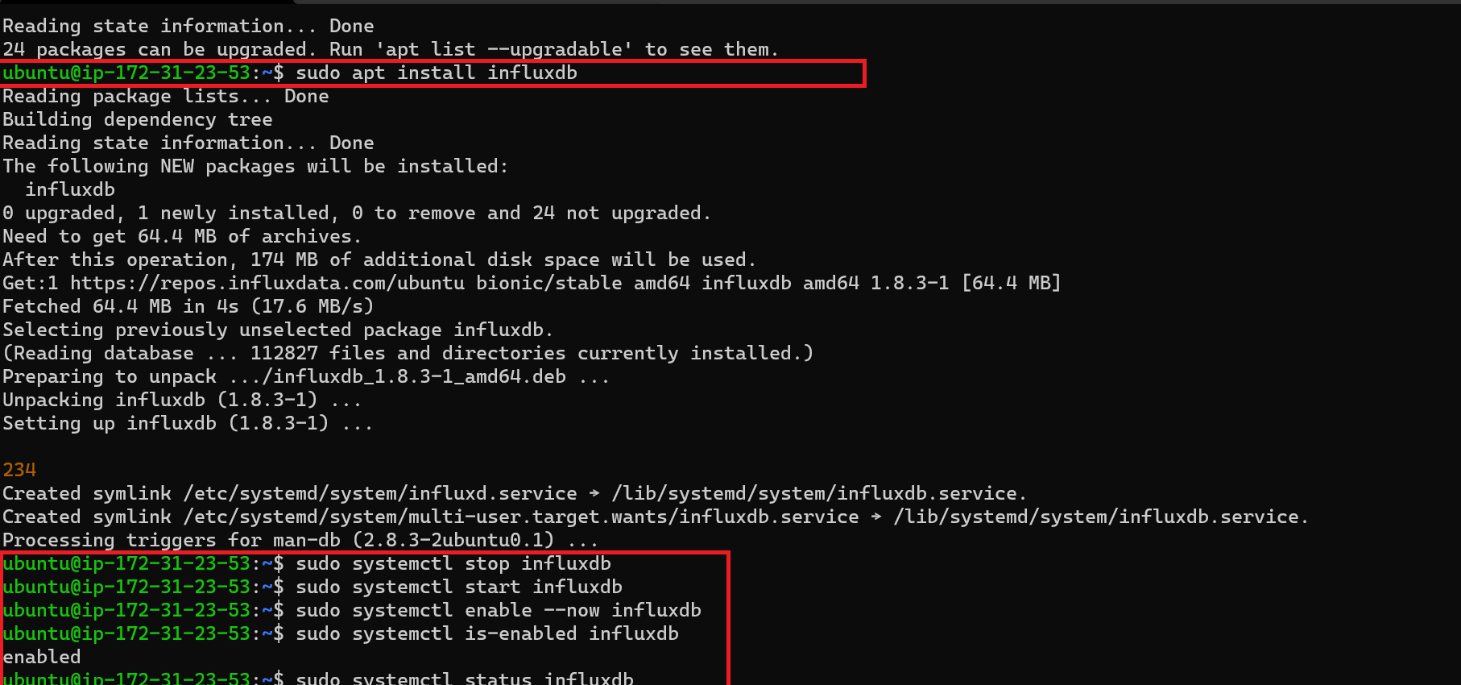

Step 2: configure influxDB:

Edit the /etc/influxdb/influxdb.conf.

Using the nano editor as shown below

sudo nano /etc/influxdb/influxdb.conf

Uncomment the ‘enable = true’ as shown below and save the file

[http]

# Determines whether HTTP endpoint is enabled.

enabled = true

# Determines whether the Flux query endpoint is enabled.

# flux-enabled = false

and restart the influxdb

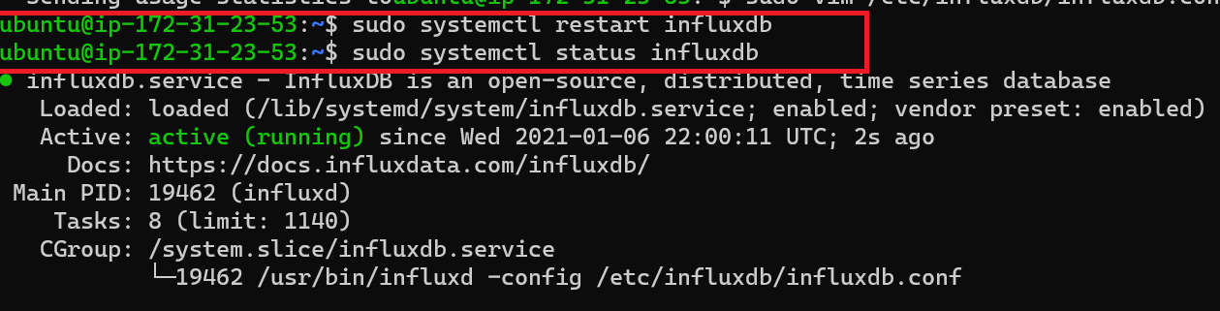

Type the following command to create user and passwd

curl -XPOST "http://localhost:8086/query" --data-urlencode "q=CREATE USER admin WITH PASSWORD 'type_password_here' WITH ALL PRIVILEGES"



Type influx at the shell to enter the influx db shell

influx -username 'admin' -password 'your_password_here'

And create a new tweet database as below

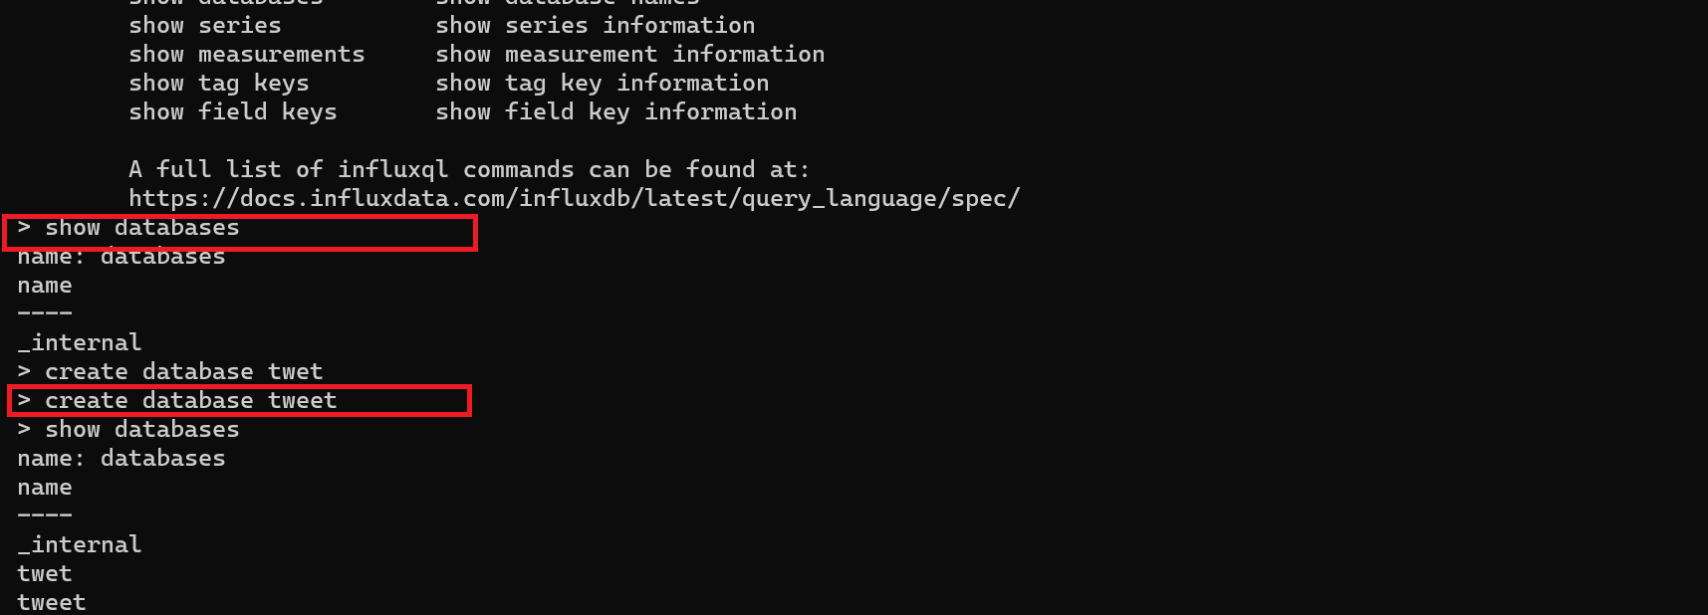

Step 3:

Then execute the program in the colab to load the nashville tweets database into influxDb:

<https://colab.research.google.com/drive/1ZeXpqp3c98XKOOPW5EW3y4vwvoSOk_HH#scrollTo=Rx9Hztq0xcH3>

Step 4: INstall the chronograph on your linux VM to run queries and visualize data from the influxDB.

Go to <https://portal.influxdata.com/downloads/> to download the chronograph

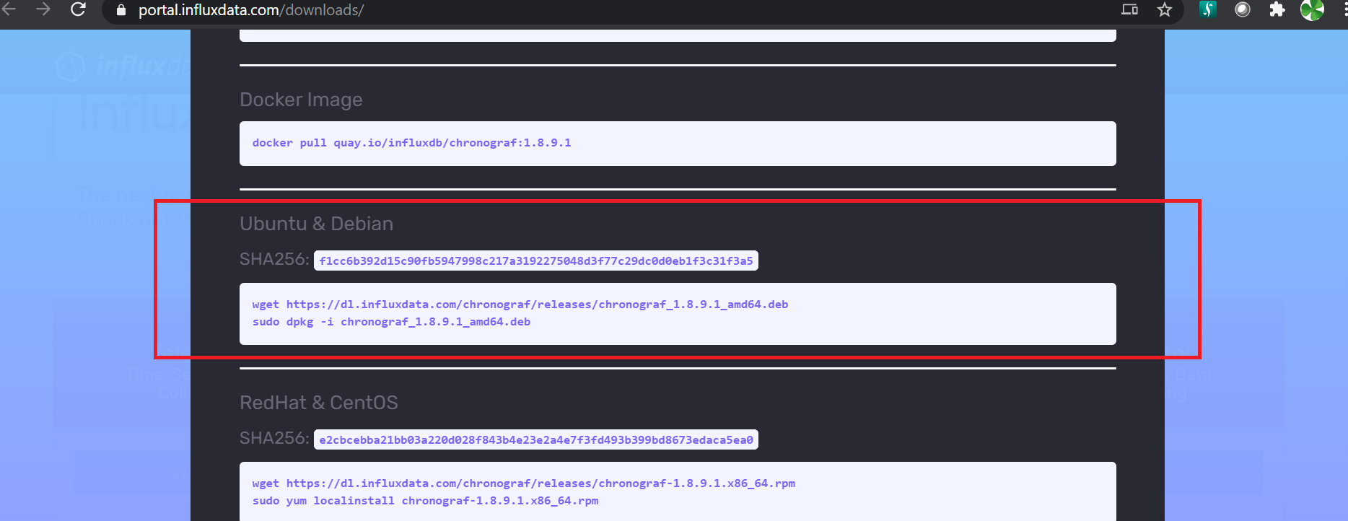

Download and unzip the package:

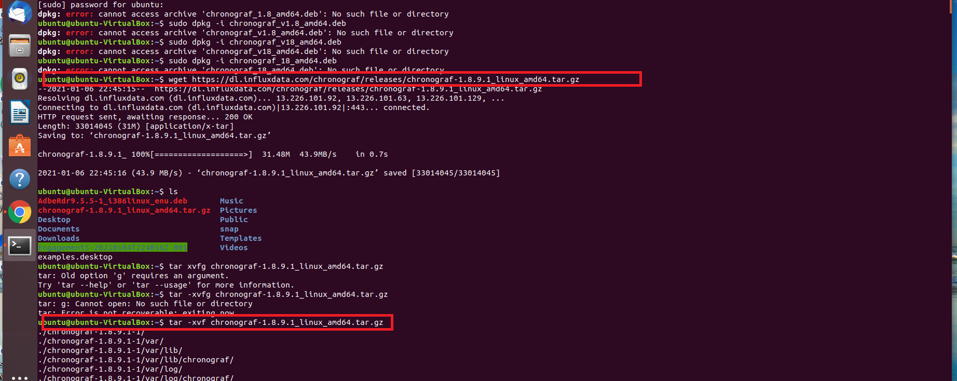

* Run the chronograph

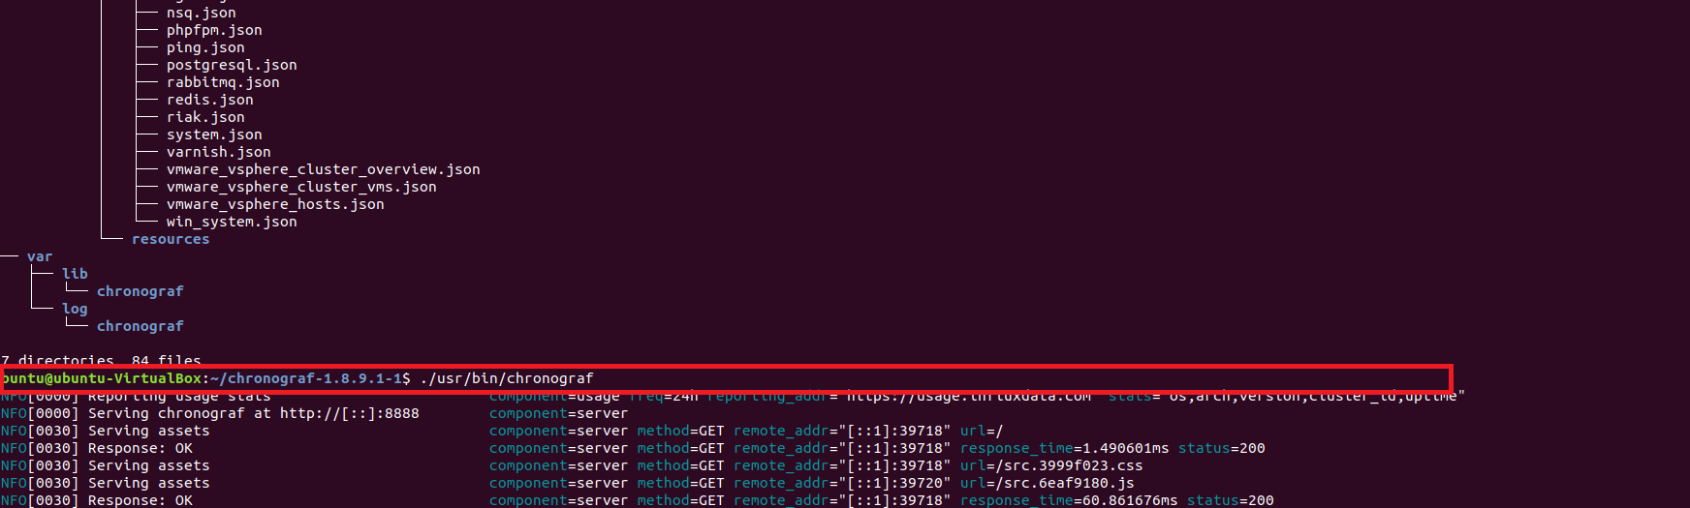

* Connect to the influxDB and view the data

